GET API call:

This API is used to get the Employee information by passing Employee ID as an input

**API:** https://apigwy-dev.internal.xxx com/gateway/EmployeePortal/1.0/getEmployeeInfo

**API Input:**

EmployeeId=589604

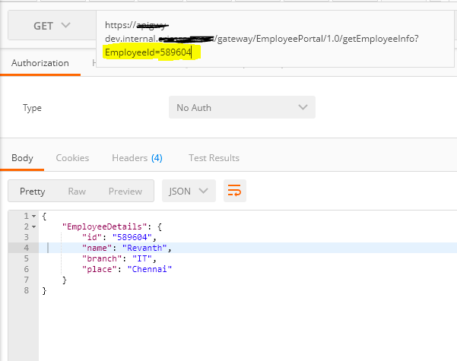

POST API call

This API is used to update the Employee information by passing Employee details as an input

**API:** https://apigwy-dev.internal.xxx com/gateway/EmployeePortal/1.0/updateEmployeeInfo

**API Input:**

{

"EmployeeDetails": {

"id": "589604",

"name": "Revanth Ch",

"branch": "IT",

"place": "Vizag"

}

}

**API Response:**

{

"Status": "Employee information got updated successful for 589604",

"EmployeeDetails": {

"id": "589604",

"name": "Revanth Ch",

"branch": "IT",

"place": "Vizag"

}

}

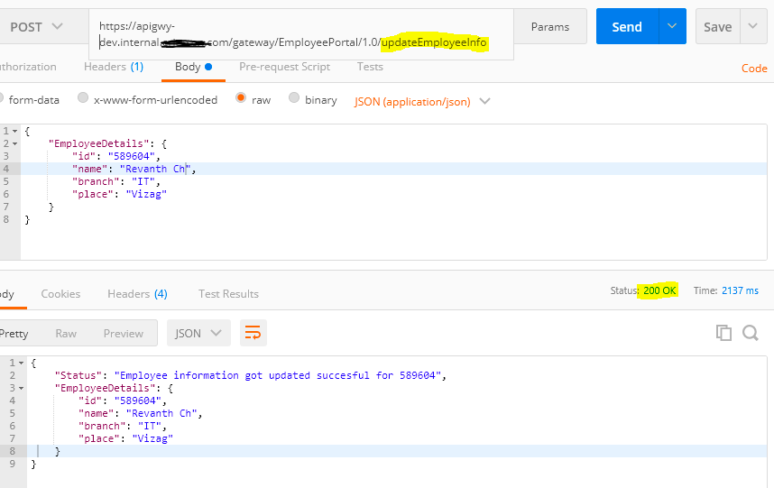

DELETE API call

This API is used to delete the Employee information by passing Employee Id as an input

**API:** https://apigwy-dev.internal.xxx com/gateway/EmployeePortal/1.0/deleteEmployeeData

**API Input:**

{

"EmployeeDetails": {

"id": "589604"

}

}

**API Response:**

{

"Status": "Employee information was deleted successful for 589604",

"EmployeeDetails": {

"id": "589604"

}

}

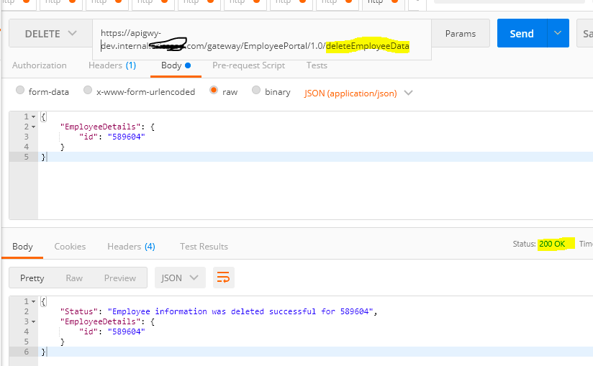

Swagger File:

API Swagger documentation of the above three API resources

{

"swagger" : "2.0",

"info" : {

"version" : "1.0",

"title" : "EmployeePortal"

},

"host" : "apigwy-dev.internal.xxxxx.com",

"basePath" : "/gateway/EmployeePortal/1.0",

"schemes" : [ "https" ],

"paths" : {

"/deleteEmployeeData" : {

"delete" : {

"description" : "This API deletes the Employee data from the backend DB using an Native API Cal",

"consumes" : [ ],

"parameters" : [ ]

}

},

"/getEmployeeInfo" : {

"get" : {

"description" : "This API which fetch the Employee data from the backend DB using an Native API Cal",

"consumes" : [ ],

"parameters" : [ ]

},

"parameters" : [ {

"name" : "EmployeeId",

"in" : "query",

"description" : "This filed id mandatory",

"required" : true,

"type" : "string"

} ]

},

"/updateEmployeeInfo" : {

"post" : {

"description" : "This API will update the Employee information using an Native API Cal",

"consumes" : [ ],

"parameters" : [ ]

}

}

}

}